UPPWISE INDIA

www.uppwise.com



**Quaterly Development Planning**

**Q1-2024**

**Feature: Execution Management - Import actuals (costs)**

**Feature Title:**

Execution Management - Import actuals (costs)

**Priority:**

High

**Submitted By:**

SPM

**Target Users:**

AXA

**Feature Description:**

This feature involves a redesign of the entire page, including the approach of health card along with the accessing and utilizing the comment feature.

**Acceptance Criteria:**

**Create Extention Hook – to configure the custom import:**

* Created a extension hook (As it is a custom specific import) and configured the service in extension hook.

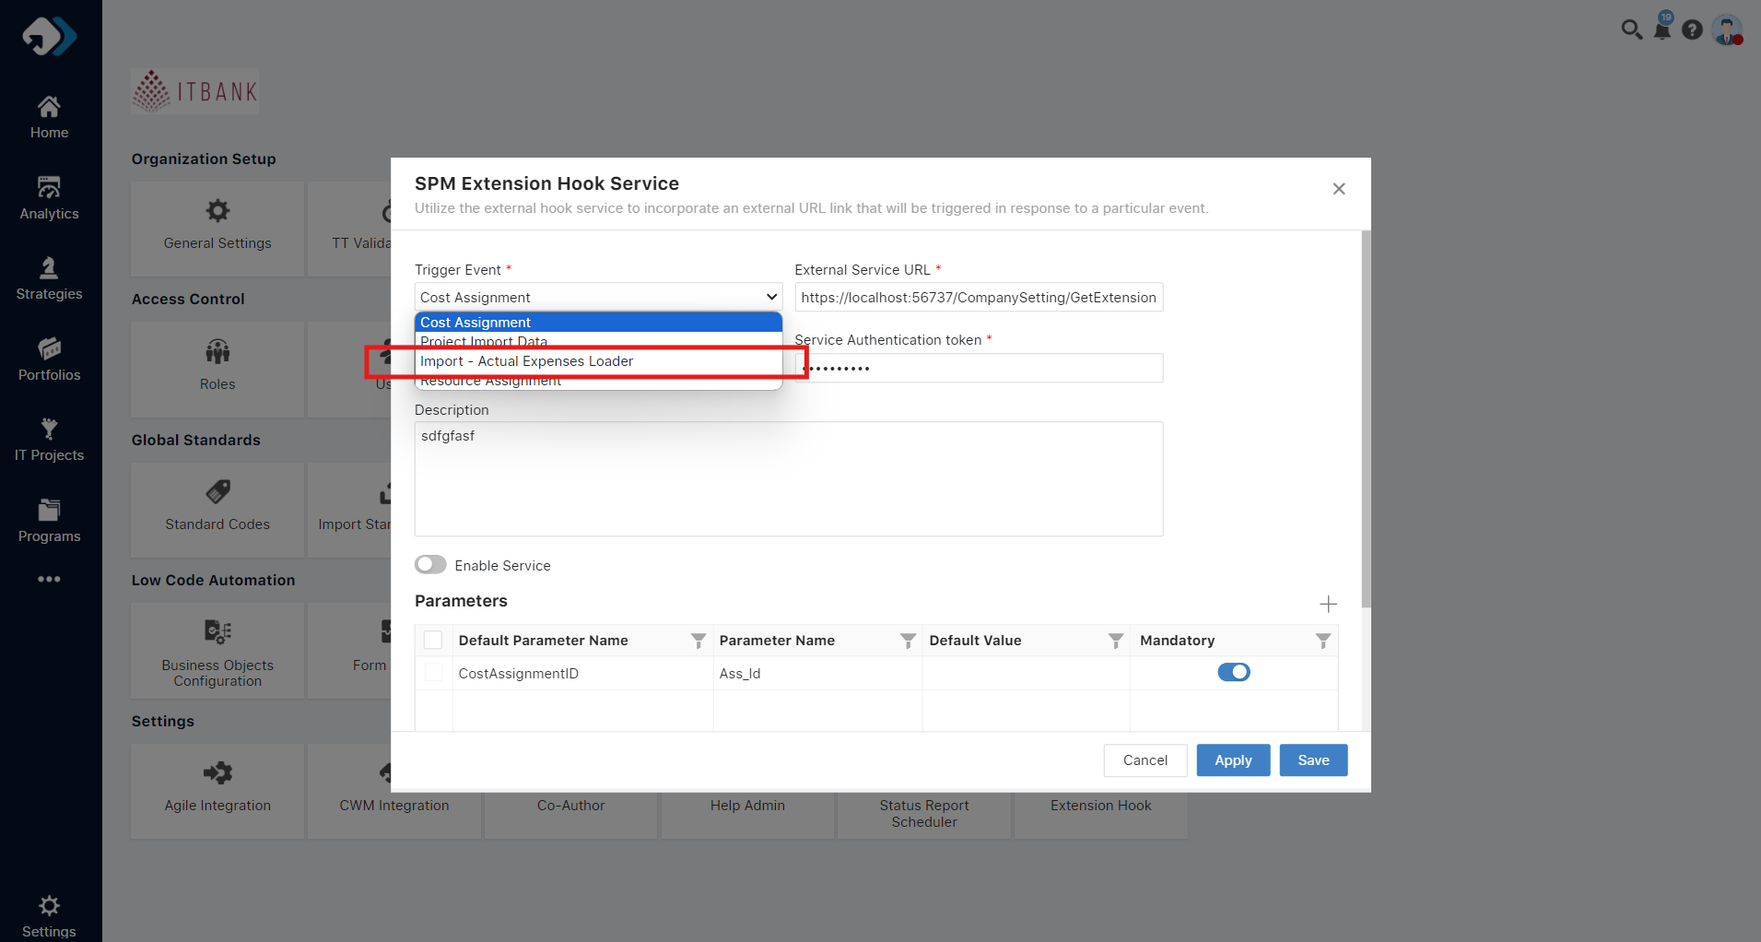

**Loader Pop-up Changes:**

* Verify that when the user selects "Import Data" from the Idea register, the loader pop-up appears with the updated title and layout.
* Confirm that a selector is added to allow the user to choose between uploading Idea or actual expenses cost data.

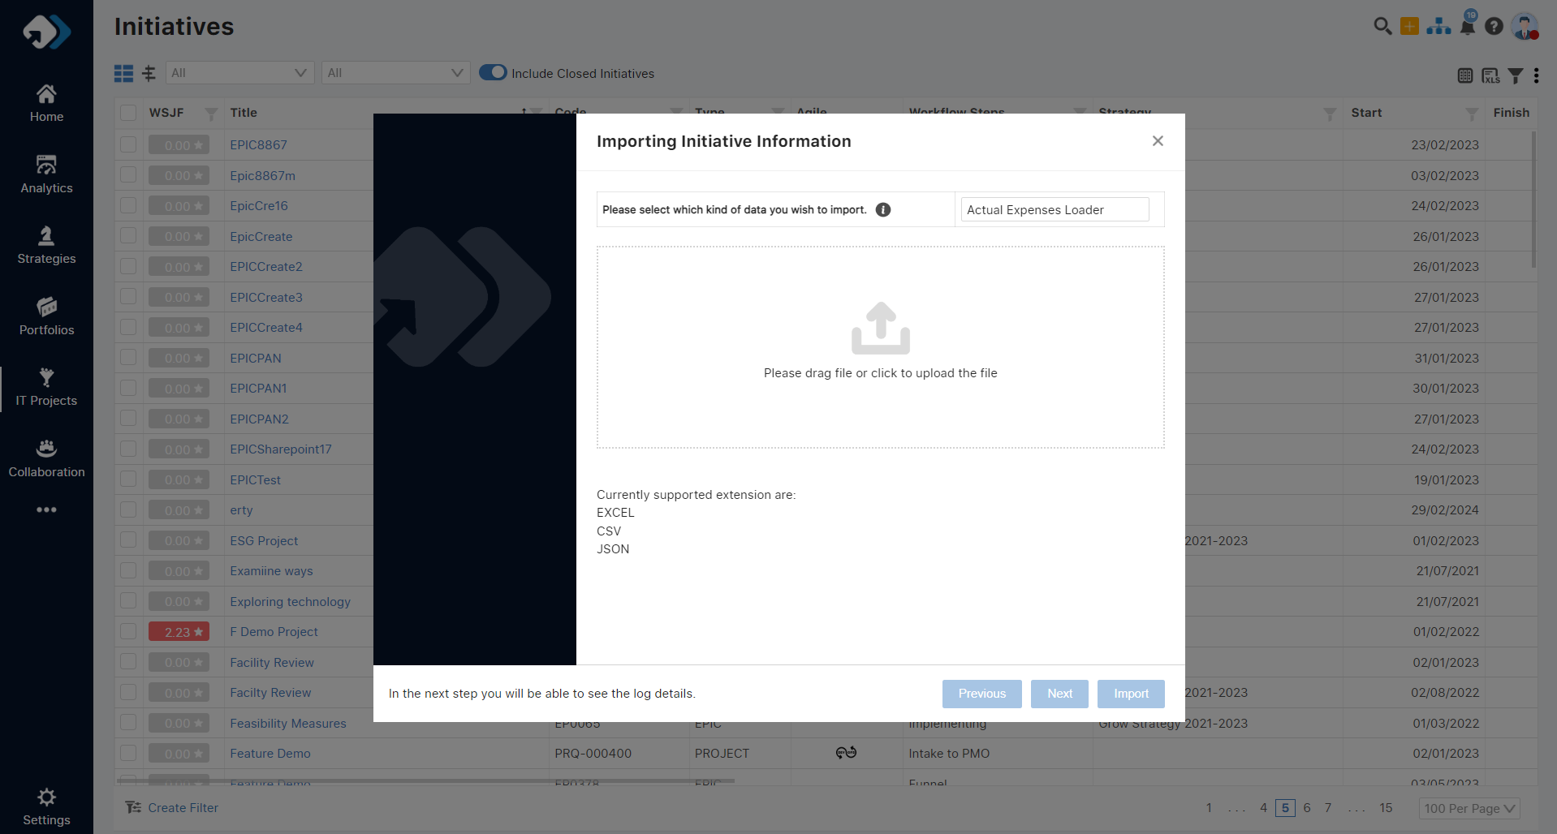

**File Validation:**

* Ensure that the loader checks if the uploaded file is correct based on the user's selection (Idea or actual expenses cost).
* Validate that the loader logs any errors encountered during file validation.

**Log Availability:**

* Confirm that a log is generated and available after the execution of the loader process.
* Verify that the log includes the following fields: Id, Process Id, Project Code, Year, Month, Cost Element Code, Value EURO, Uploaded Date, Uploaded By, ASS ID, Process Status, Process Remarks, Process Date.

**Successful Record Loading:**

* After upload a file a log will be visible in the grid. Which can be downloadable.
* In case the record is loaded correctly, it will be wrote in the log file with a properly status and description.

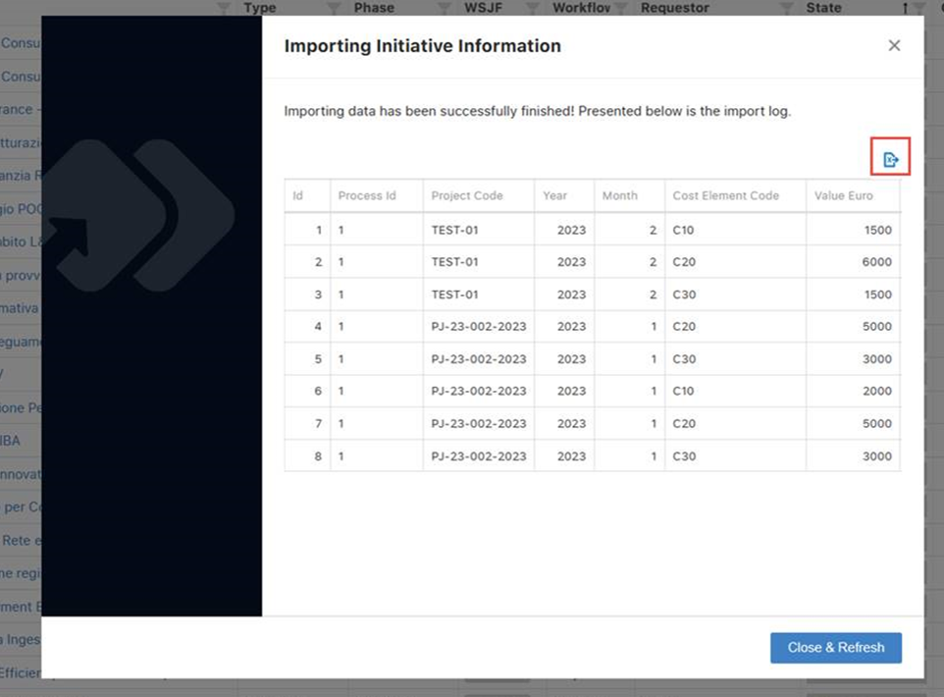

**Error Handling and Logging** (Error check request raised by Armando):

* In case in the file a project and cost account code is present more than one time. We have to check this condition and discard all the duplicated rows.
* We have to check the file with the selection of the kind of loader and if the file is not compatible with the kind of file attached by the user we don’t unfreeze the load button.
* We have to warning the user to upload the same file more than one time
* The forecast values cannot be set
* When the project is in status closed, avoid to set / update actuals
* The project code shall exist
* The cost element shall exist in the table
* The Actuals period should be in the project timeline
* All the cost must be uploaded in the main task
* If the cost element doesn’t exist shall be created